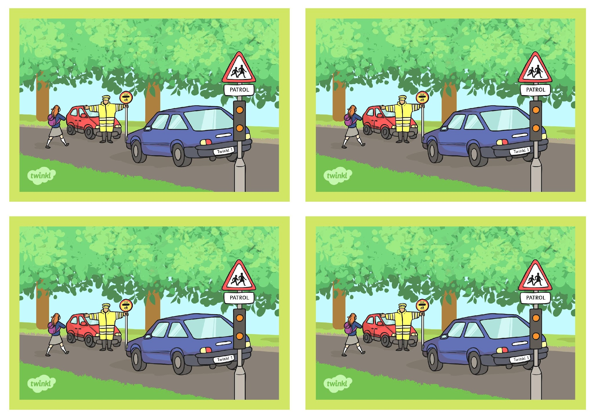
Controlling Devices: Flowol

Challenge Cards

Controlling Devices: Flowol

Challenge Cards

Controlling Devices: Flowol

Challenge Cards

Controlling Devices: Flowol

Challenge Cards

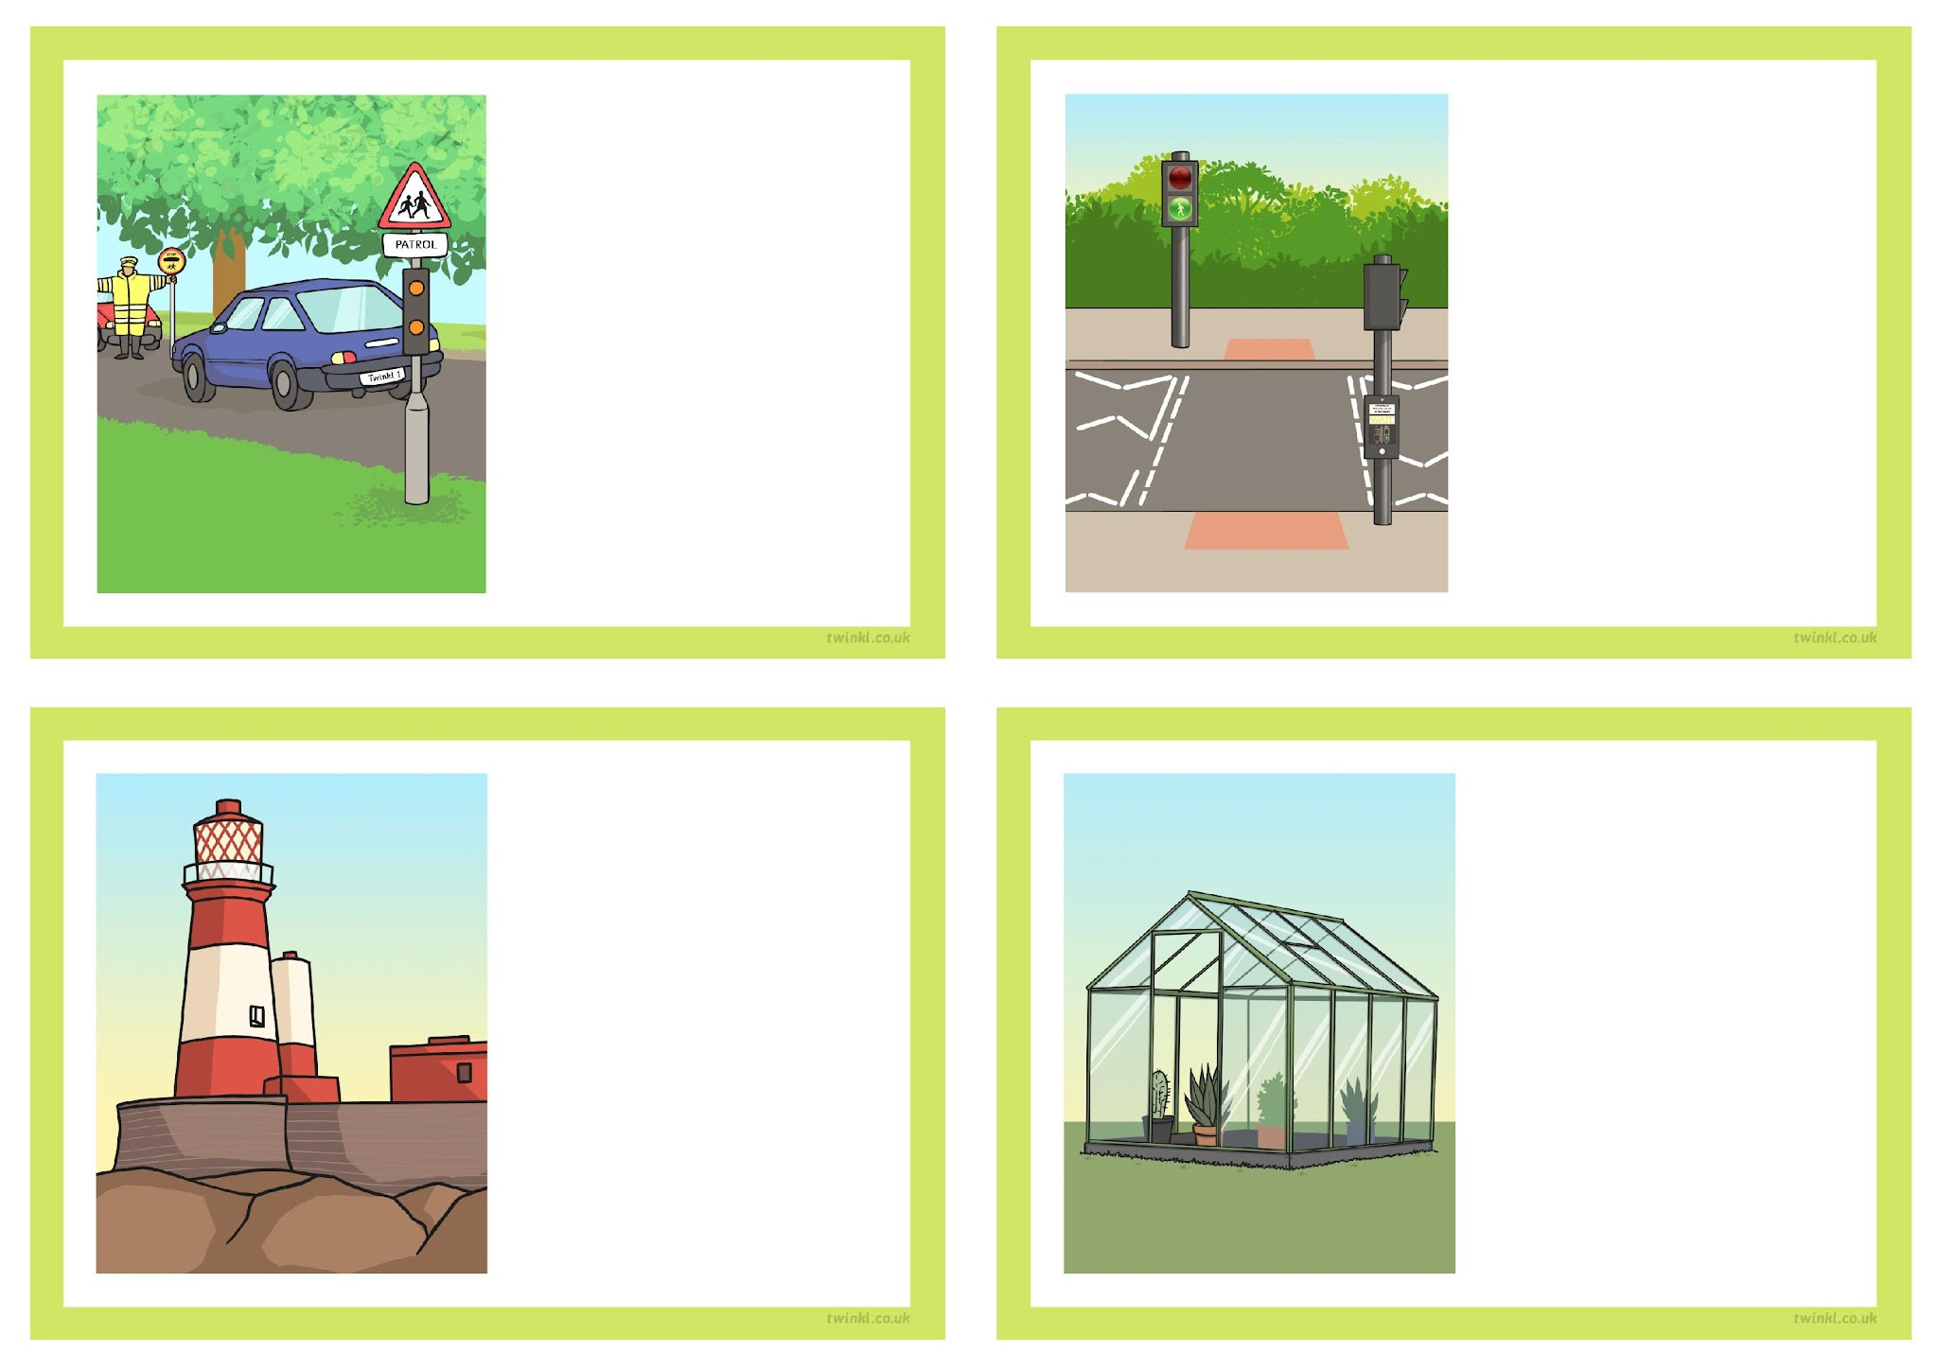
Can you program the lighthouse to use the lamp and the foghorn when the Sun is not shining?

Can you control the zebra crossing lights to make them flash on and
off repeatedly?

Can you make the lights work correctly on the crossing patrol?

Can you control different outputs on the computer controlled greenhouse, based on the inputs?

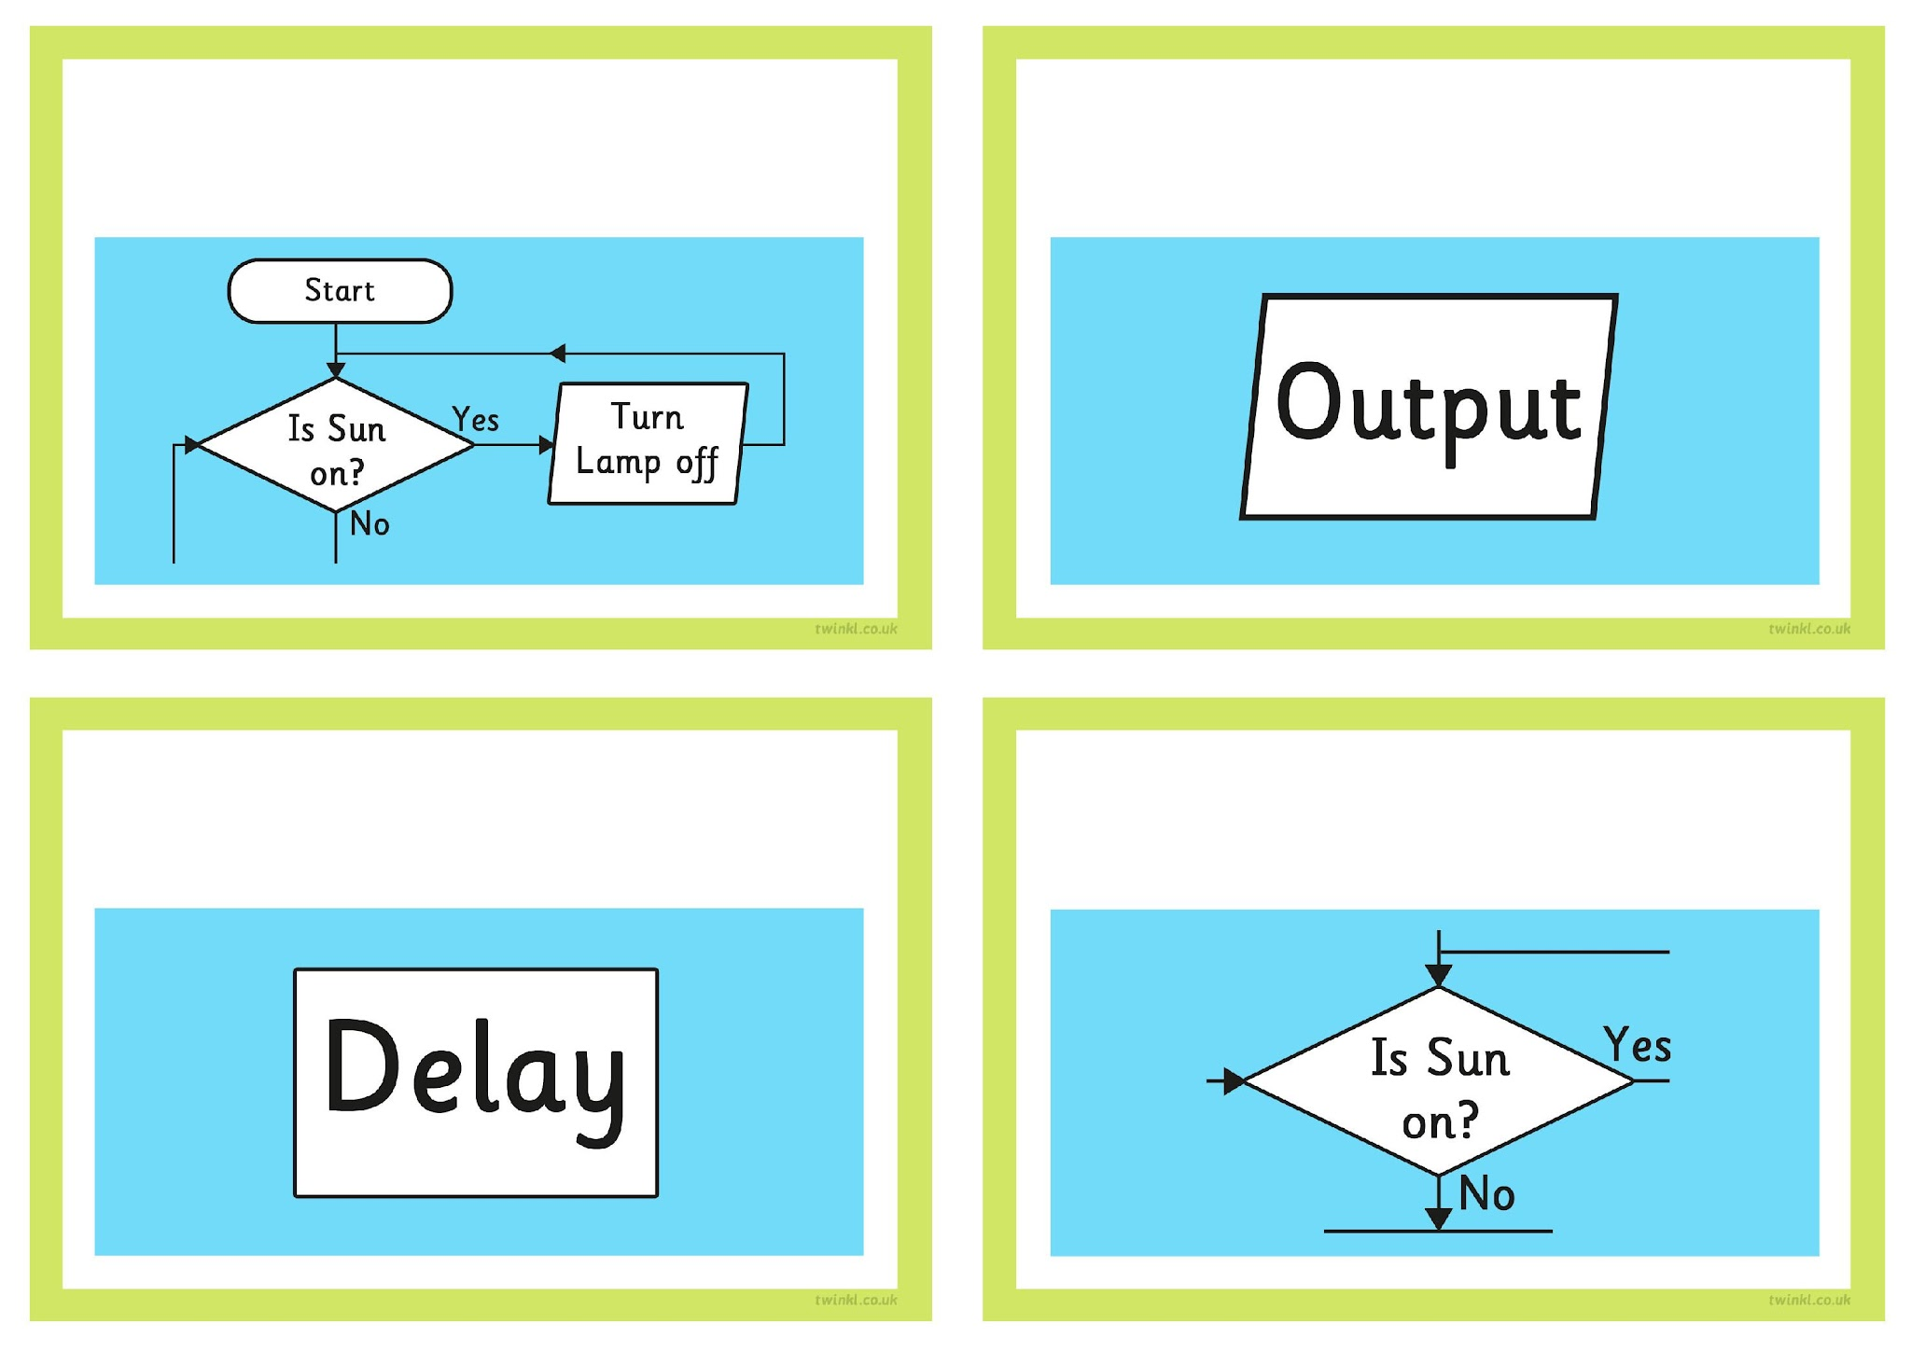
Design your own flowchart algorithm that uses a loop or repeat sequences.

Design your own flowchart algorithm that controls two or more outputs at once.

Design your own flowchart algorithm that uses a delay symbol.

Design your own flowchart algorithm that uses a decision (YES/NO) symbol.

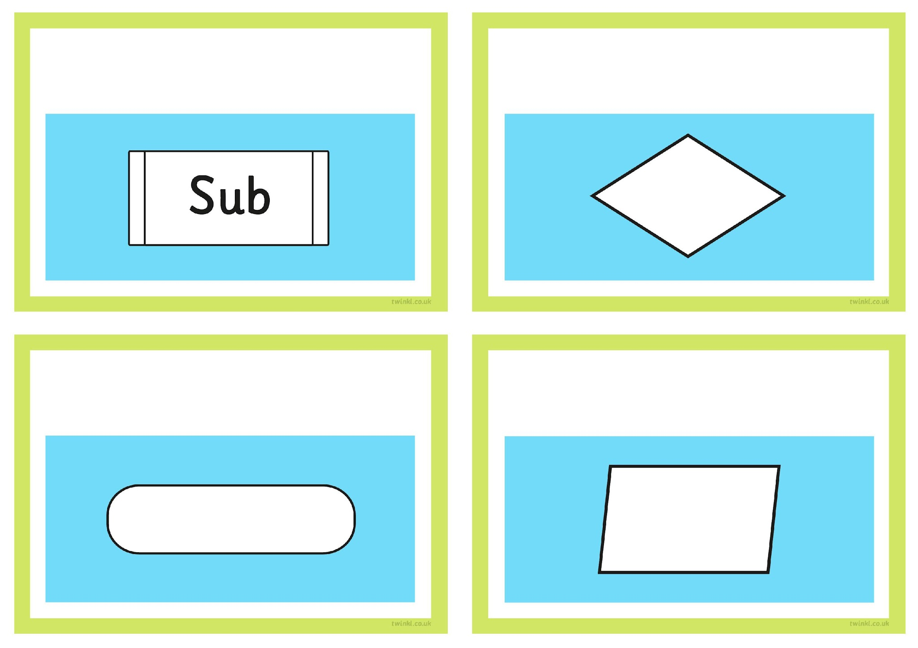
Describe how this symbol is used.

Describe how this symbol is used.

Describe how this symbol might be used.

Describe how this symbol might be used.

